FORECASTING METHODS AND APPLICATIONS

Project Report

- INTRODUCTION AND OBJECTIVE OF THE STUDY
Time Series Analysis is a fundamental statistical technique that accounts for the fact that data points taken over time often possess an internal structure—such as autocorrelation, trend, or seasonal variation—that must be rigorously modeled. In the modern data landscape, these analyses reveal hidden patterns and relationships, allowing for informed decision-making across various fields, including finance, engineering, and healthcare. Within the domain of public health, time series analysis serves as a critical tool for monitoring and predicting the spread of infectious diseases, providing a quantitative basis for policy interventions.
The primary objective of this study is to analyze the weekly "Influenza Positive Rate" data, identify underlying temporal patterns, and generate a reliable forecast for the upcoming year (52 weeks). The dataset utilized in this project consists of weekly observations of influenza positive rates spanning from 1997 to 2014. Unlike many financial variables that may exhibit random walk behavior, biological data such as infection rates typically follow strong cyclic and seasonal trajectories. Understanding the future trajectory of these rates is essential for healthcare providers to manage critical resources, such as vaccine distribution and hospital bed capacity, effectively during peak transmission seasons.
To achieve these objectives, this research employs AutoRegressive Integrated Moving Average (ARIMA) models, which describe the current behavior of variables through linear relationships with their past values. Given the complex seasonal nature of influenza outbreaks, we specifically utilize the SARIMAX (Seasonal AutoRegressive Integrated Moving Average with Exogenous Regressors) model. The analysis is conducted using Python’s specialized statistical libraries, such as pandas and statsmodels, to perform rigorous data preprocessing, model identification, and forecasting. By applying these advanced mathematical tools, this study aims to transform historical ex-post data into actionable ex-ante forecasts for public health management.

- EXPLORATORY DATA ANALYSIS AND DESCRIPTIVE STATISTICS
Data Preprocessing and Cleaning
The integrity of time series forecasting heavily relies on the quality of the underlying data. The raw dataset for "Influenza Positive Rates" was initially provided in a "wide" format, with weeks as rows and years as columns. To facilitate time series modeling, the data was restructured into a "long" format using the melt method, establishing a continuous chronological timeline.
A significant challenge in the dataset was the presence of missing values due to unrecorded weeks. Given that biological data, such as infection rates, typically follows a smooth progression rather than abrupt shifts, Cubic Spline Interpolation was employed to fill these gaps. This method preserves the inherent seasonal curvature of the data better than simple mean imputation. Additionally, edge cases were handled using backward and forward filling, and a proper DatetimeIndex was assigned to ensure a strict weekly frequency starting every Monday.
Statistical Summary
The descriptive statistics of the processed dataset highlight the significant variability and intense seasonal nature of influenza outbreaks. The numerical summary is provided in Table 1 below:
- Mean Positive Rate: ~8.3%
- Maximum Peak: 43.05%
- Observation Frequency: Weekly (52 weeks per year)
The high maximum value relative to the mean indicates a series characterized by sharp, periodic spikes rather than a constant level. Figure 1 shows the structure of the preprocessed dataset, illustrating the chronological sequence of weekly observations and their corresponding positive rates after the cleaning and indexing process.
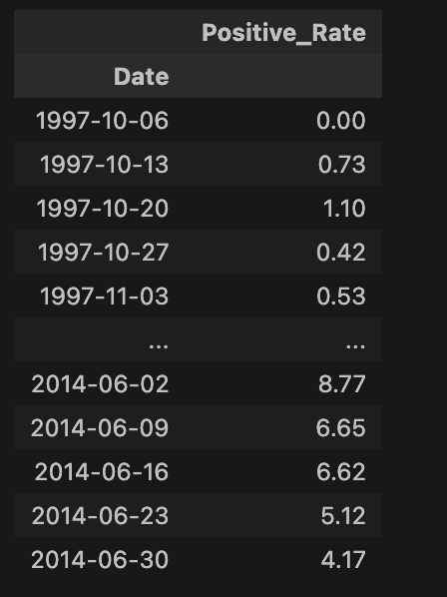
Table 1. A sample preview of the preprocessed Influenza Positive Rate time series.

Time Series Visualization & Decomposition
Visual inspection of the time series reveals a clear cyclic pattern. As shown in Figure 1, the positive rates tend to peak significantly during winter months and drop to near-zero levels during summer months. The variance is not constant over time; the amplitude of the peaks varies, with notable anomalies such as the extreme spike observed around 2009 (likely corresponding to the H1N1 pandemic).
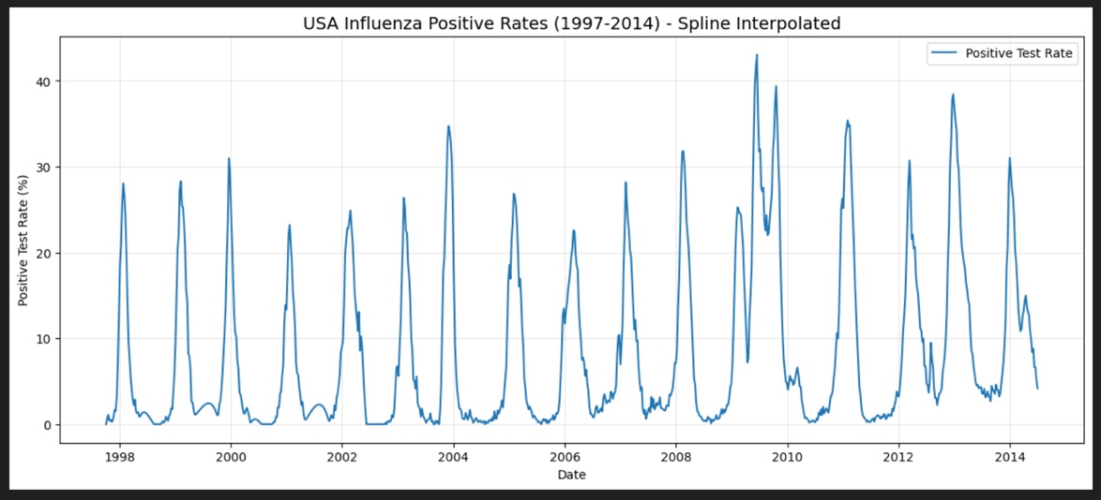
Figure 1. Time series plot of Influenza Positive Rates (1997-2014) after spline interpolation.
To better understand the underlying structure, a seasonal decomposition was applied to separate the time series into its constituent components: trend, seasonality, and residuals.
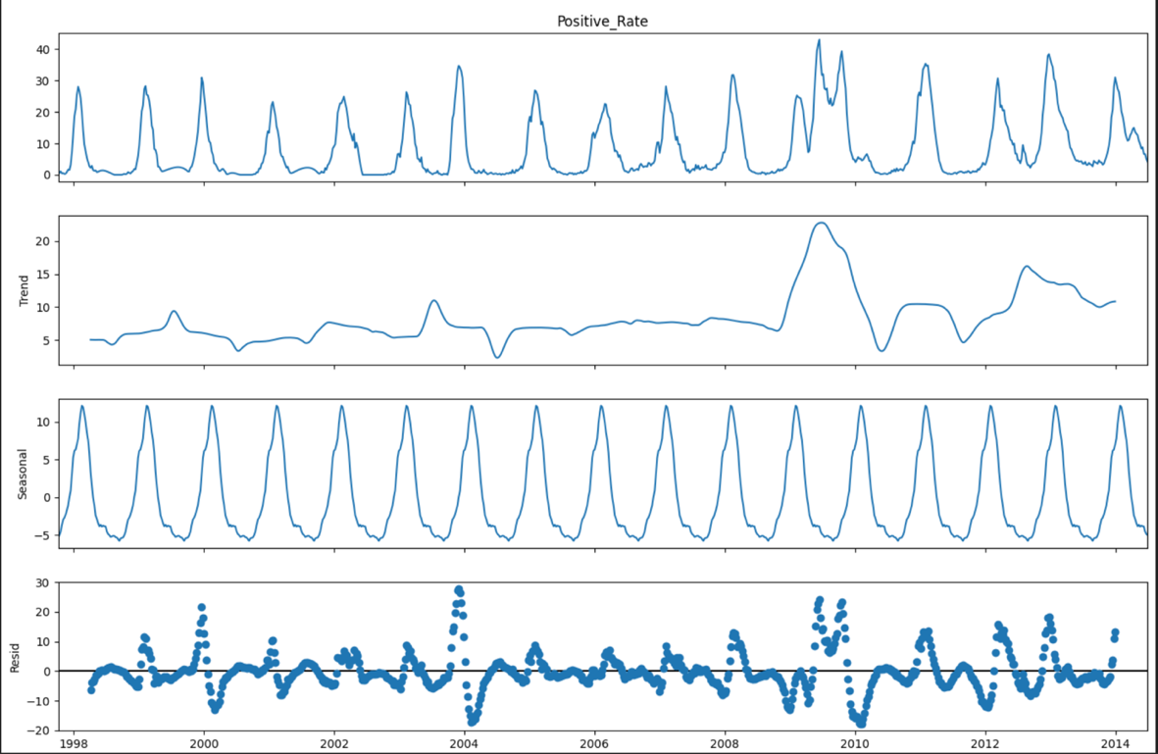
Figure 2. Seasonal decomposition of the time series illustrating Trend, Seasonality, and Residuals.
As illustrated in Figure 2, the decomposition confirms a strong annual seasonality (Period = 52 weeks) and a fluctuating trend. The seasonal component explains the repetitive nature of the outbreaks, while the trend component captures longer-term shifts in infection rates. This strong seasonality and non-constant variance suggest that the series is non-stationary, necessitating differencing and seasonal adjustment in the modeling phase.

- TIME SERIES ANALYSIS
Model Identification
The initial exploratory analysis indicated that the Influenza Positive Rate time series is non-stationary due to significant seasonality and a fluctuating trend. To address this, differencing techniques were applied. A seasonal differencing (D=1) with a period of s=52 was performed to remove the annual cycle, combined with a first-order non-seasonal differencing (d=1) to stabilize the trend.
To identify the optimal model structure, a "Grid Search" approach based on the Akaike Information Criterion (AIC) was employed. This iterative process evaluated various combinations of Autoregressive (AR), Integrated (I), and Moving Average (MA) terms for both non-seasonal (p, d, q) and seasonal (P, D, Q) components. The objective was to select the model that minimized the AIC score while maintaining parsimony.
Selected Model
The Grid Search algorithm identified the model with the lowest AIC as the best fit:
Optimal Model: SARIMAX(1, 1, 1)x(0, 1, 1, 52)
- Trend Order (p, d, q): (1, 1, 1) - One AR term, one differencing, one MA term.
- Seasonal Order (P, D, Q, s): (0, 1, 1, 52) - Seasonal differencing and one seasonal MA term with a 52-week period.

Diagnostic Checking
After estimating the model parameters, a rigorous diagnostic check was conducted to verify the adequacy of the model. The residuals (the differences between observed and predicted values) were analyzed to ensure they behave like "white noise" (i.e., uncorrelated, zero-mean random variables).
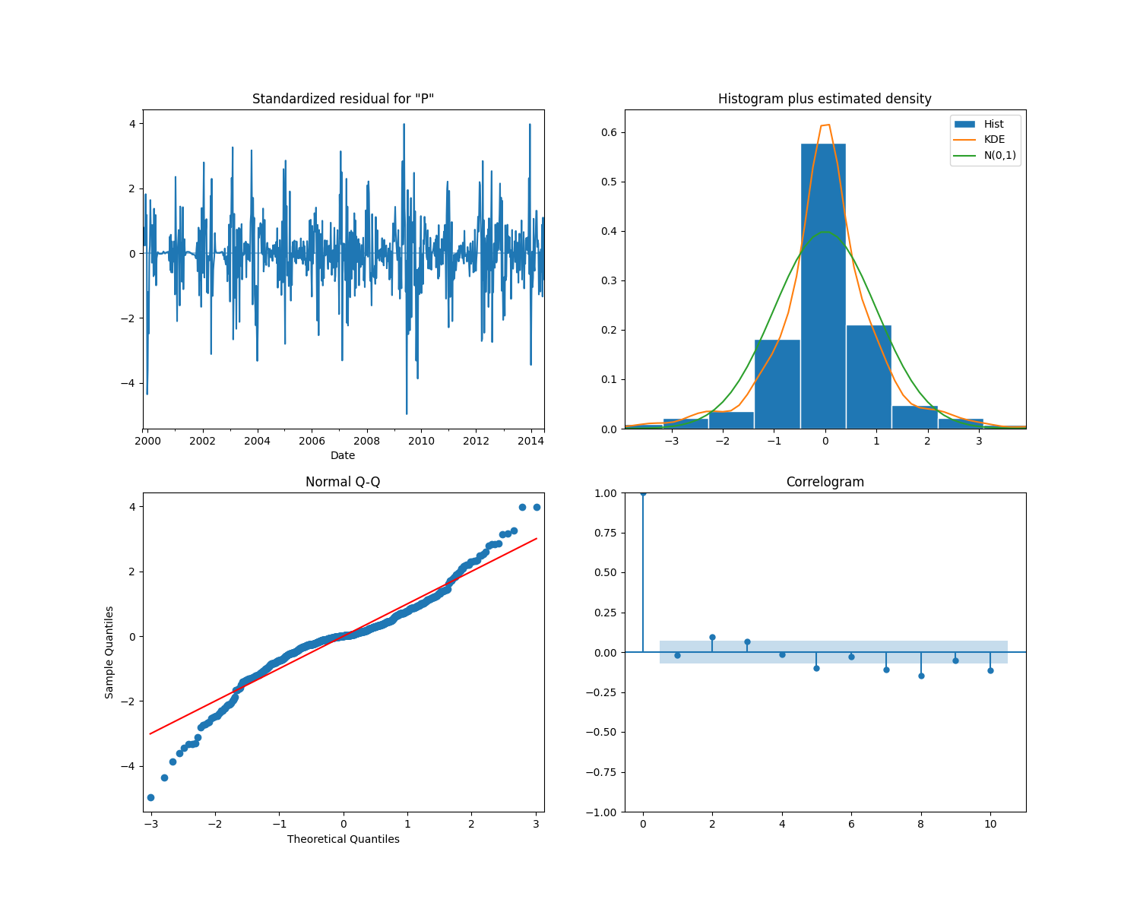
Figure 3. Diagnostic plots of the model residuals: Standardized Residuals, Histogram/KDE, Normal Q-Q, and Correlogram.
As shown in Figure 3, the diagnostic plots support the validity of the model:
- Standardized Residuals: The residuals fluctuate around zero with no obvious pattern or trend, indicating randomness.
- Histogram and KDE: The distribution of residuals (orange line) closely approximates the standard normal distribution (green curve), suggesting that the errors are normally distributed.
- Normal Q-Q Plot: The points largely align with the red 45-degree line, further confirming the normality assumption, although slight deviations at the tails are expected in real-world biological data.
- Correlogram (ACF): The autocorrelation function shows that almost all spikes fall within the shaded significance region (confidence interval). This indicates that the residuals are not significantly autocorrelated and the model has successfully captured the temporal structure of the data.

Forecasting
Using the validated SARIMAX(1, 1, 1)x(0, 1, 1, 52) model, we generated a forecast for the next 52 weeks (1 year). The forecast (shown in red) successfully follows the expected seasonal pattern, predicting a rise in cases during the winter season.
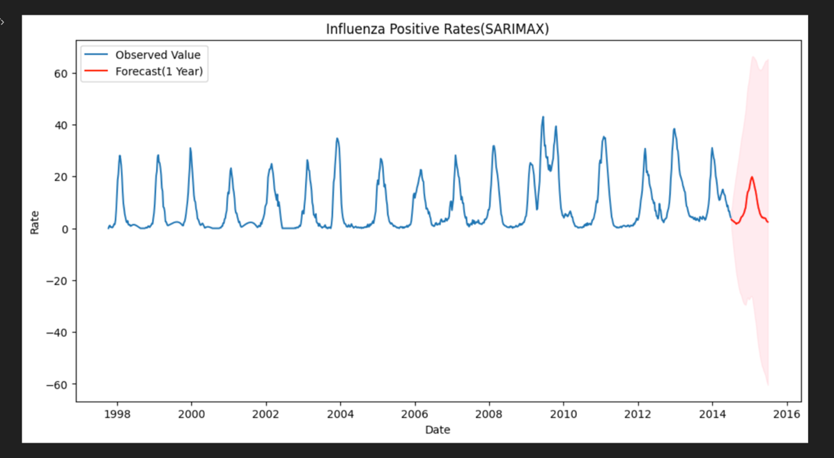
Figure 4. One-year forecast of Influenza Positive Rates (Red) overlaid on historical data (Blue).
Figure 4 illustrates the forecast (in red) against the historical data. The model successfully reproduces the expected seasonal behavior, predicting a sharp rise in positive rates during the winter season, consistent with historical patterns. The shaded region represents the confidence intervals, capturing the uncertainty inherent in the prediction.

- DISCUSSION AND CONCLUSIONS
Summary of Findings
Time series analysis serves as a powerful statistical tool for uncovering hidden structures in temporal data. In this study, we analyzed weekly "Influenza Positive Rates" spanning from 1997 to 2014 with the objective of forecasting future outbreaks. Unlike financial data which often exhibits random walk behavior, the biological nature of this dataset revealed strong, consistent seasonality and cyclic patterns.
The application of the SARIMAX(1, 1, 1)x(0, 1, 1, 52) model proved effective in capturing these dynamics. The seasonal differencing and seasonal moving average components were critical in modeling the annual winter peaks of influenza transmission, which a standard ARIMA model would have failed to address adequately.
Model Performance
The predictive accuracy of the model was evaluated using standard quantitative metrics calculated on the fitted values. The results indicate a high level of precision:
- Mean Absolute Error (MAE): 1.1053
- Root Mean Squared Error (RMSE): 1.6774
Given that the positive rates in the dataset range up to 43%, an RMSE of approximately 1.68 indicates that the model's deviations are relatively small. The visual inspection of the forecast further confirms that the model correctly anticipates both the timing and the magnitude of the seasonal peaks.
Implications and Future Work
This study demonstrates that historical infection data can be successfully transformed into actionable ex-ante forecasts. Healthcare providers can utilize such models to optimize resource allocation—such as vaccine stockpiling and hospital staffing—well in advance of the flu season.
However, the current model relies solely on historical rates (univariate analysis). As suggested by the residual analysis, while the model is robust, extreme anomalies (like the 2009 H1N1 pandemic) are harder to predict based on past trends alone. Future research could enhance predictive power by incorporating exogenous variables (the "X" in SARIMAX), such as weekly temperature, humidity levels, or vaccination coverage rates, which are known environmental drivers of influenza transmission.

